**Multi-phenotype inter-functional clustering visualization results**

Jin Chen -- Jan 25 2016

Software: NPM and OLIVER

Data: Phi2, qESV and qI from DEPI, gene information from TAIR * only positive qI logged fold change values are used

Flat light, cluster 1: high Phi2, mid qE, mid qI

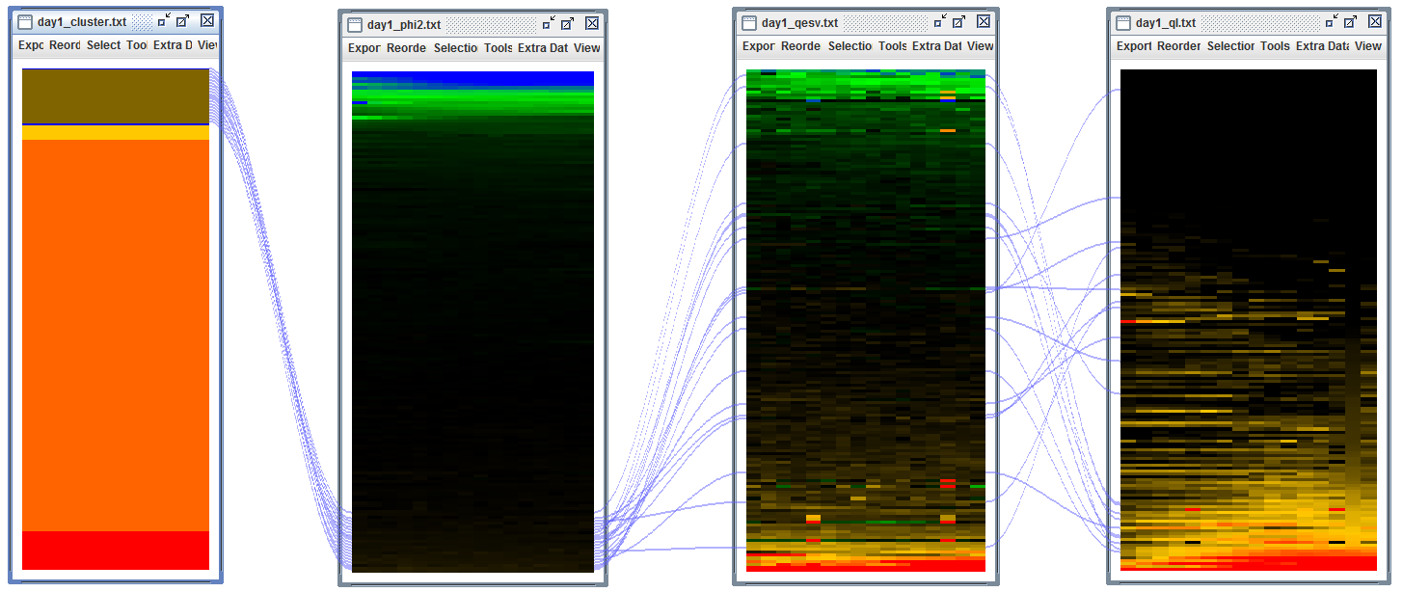

Flat light, cluster 2:low Phi2, low qE, mid qI

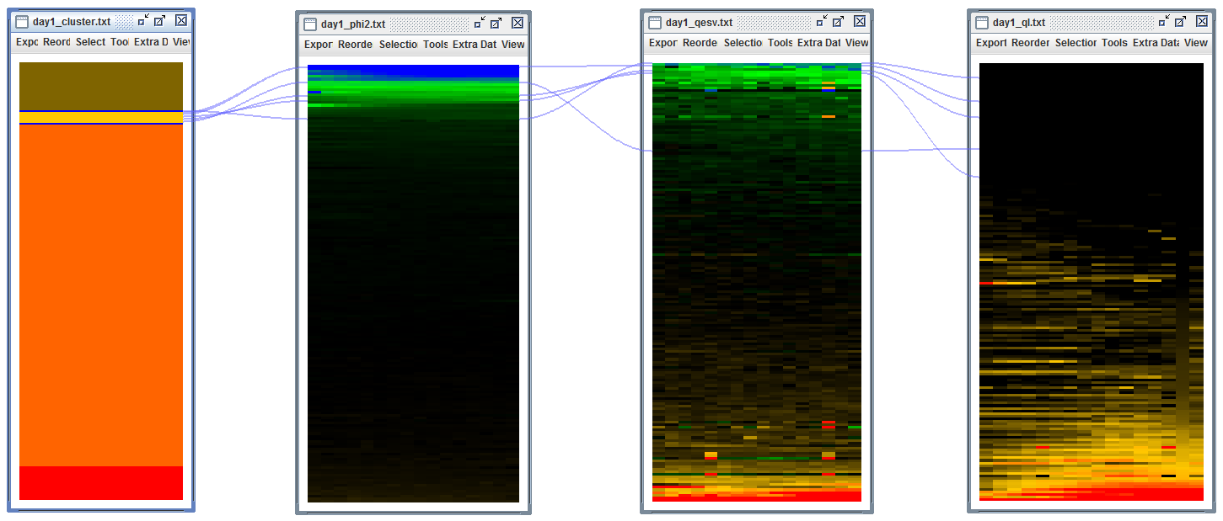

Flat light cluster 3: mid Phi2, mid qE, mid qI

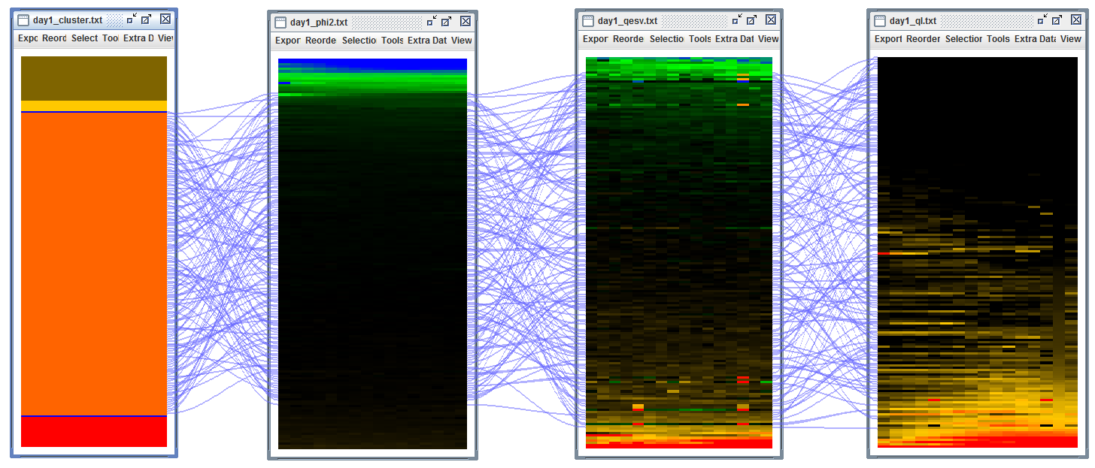

Flat light cluster 4: low Phi2, high qE, high qI

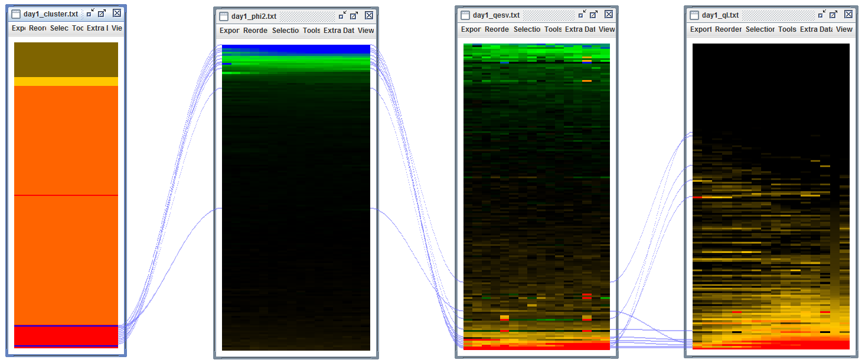

Flat day outlier 1: low Phi2, low qE and high q

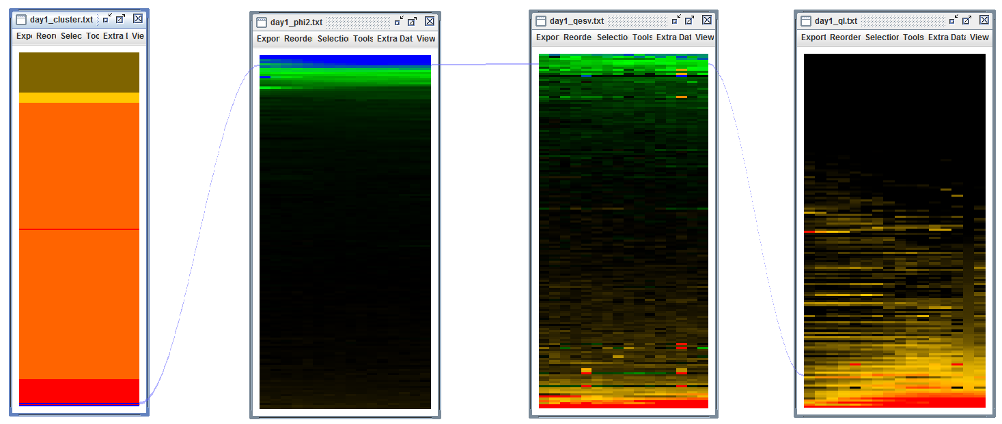

Sine light, cluster 1: Low Phi2, high qE, high qI

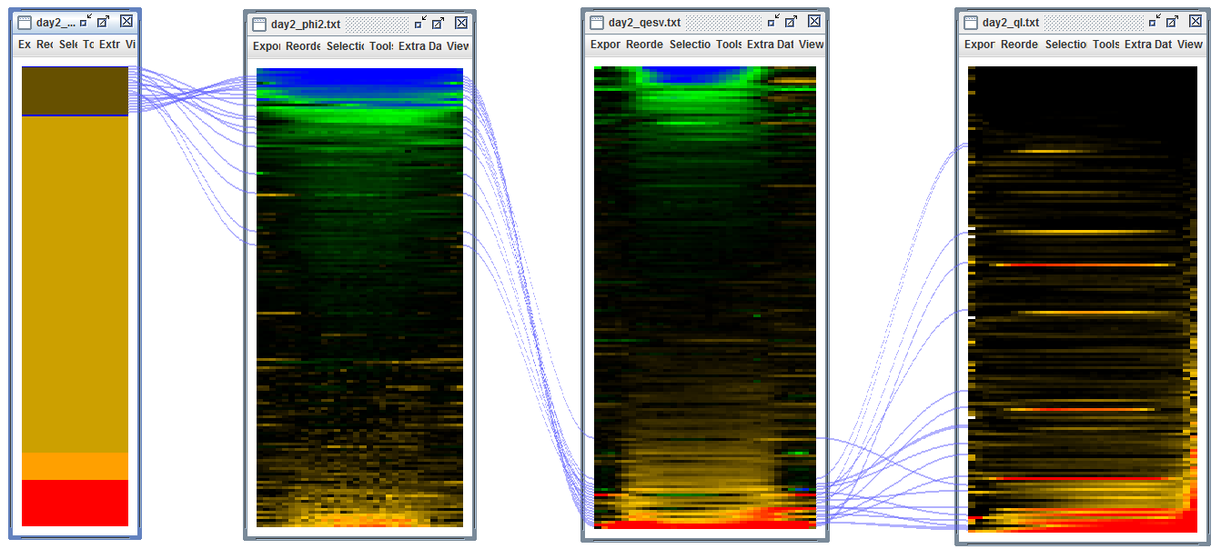

Sine light, cluster 2: Mid Phi2, mid qE, mid qI

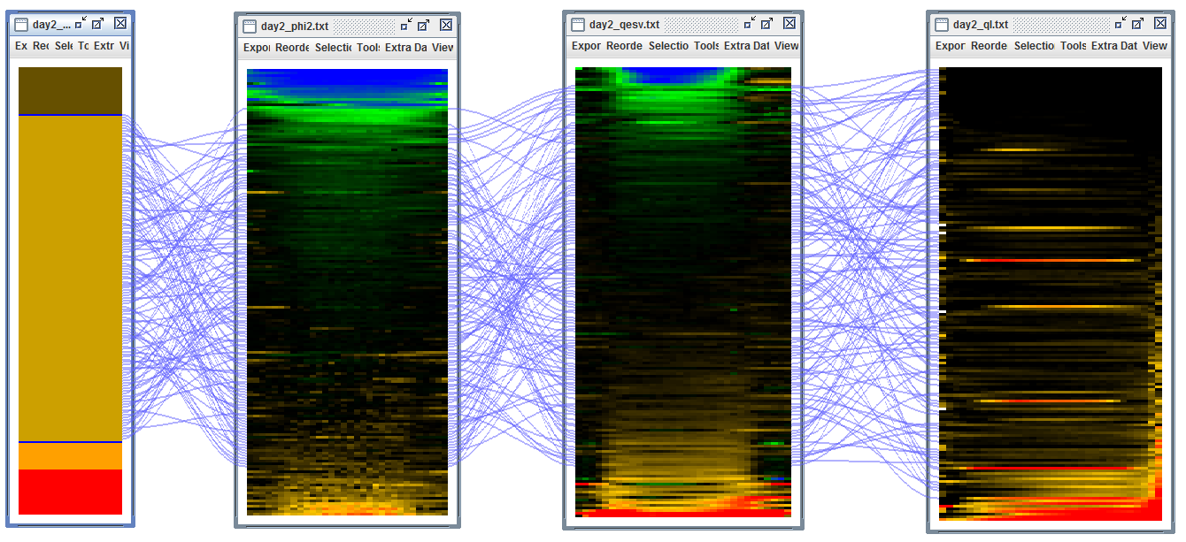

Sine light, cluster 3: low Phi2, low qE, high qI

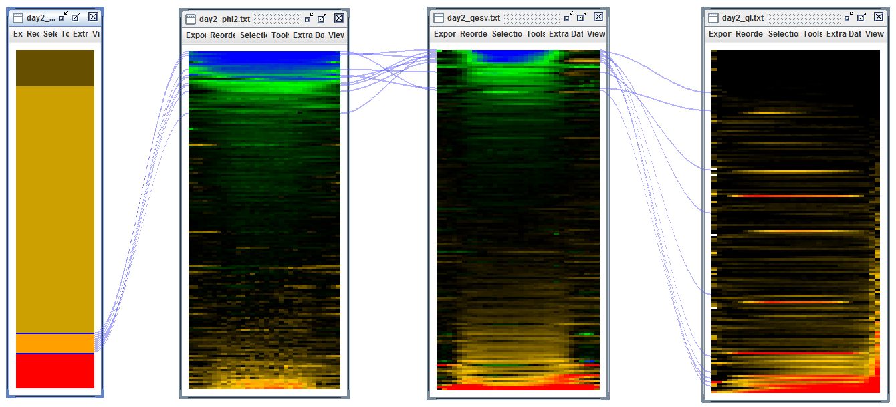

Sine light, cluster 5: High Phi2, mid qE, mid qI

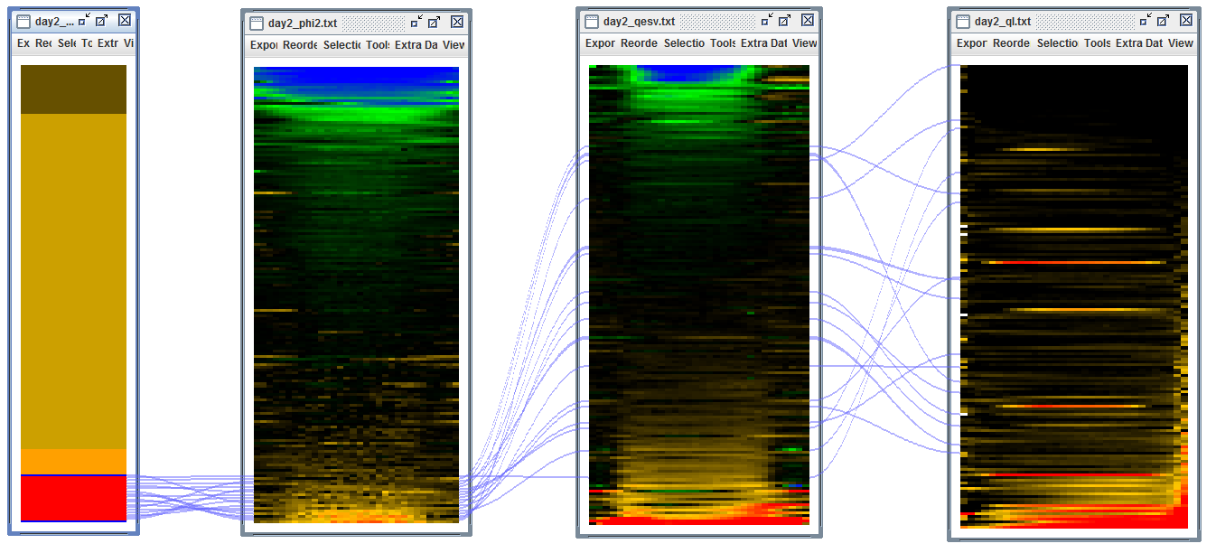

Fluctuating light, cluster 1: Low Phi2, low qE, mid qI

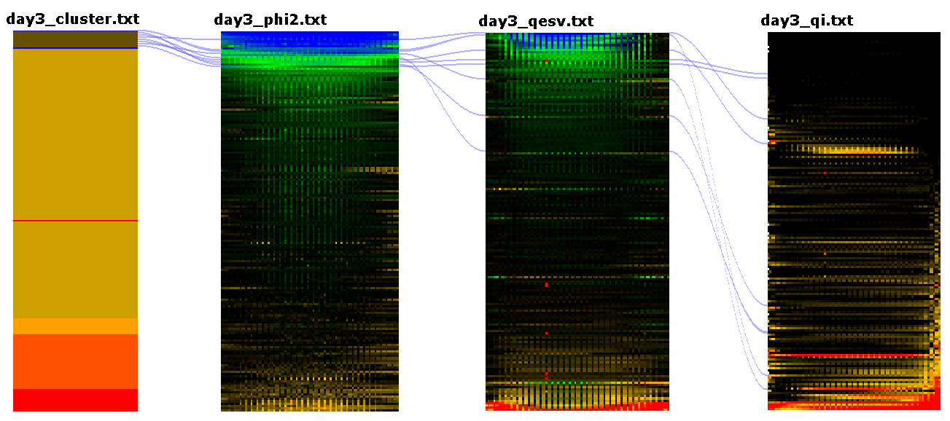

Fluctuating light, cluster 2: mid Phi2, mid qE, mid qI

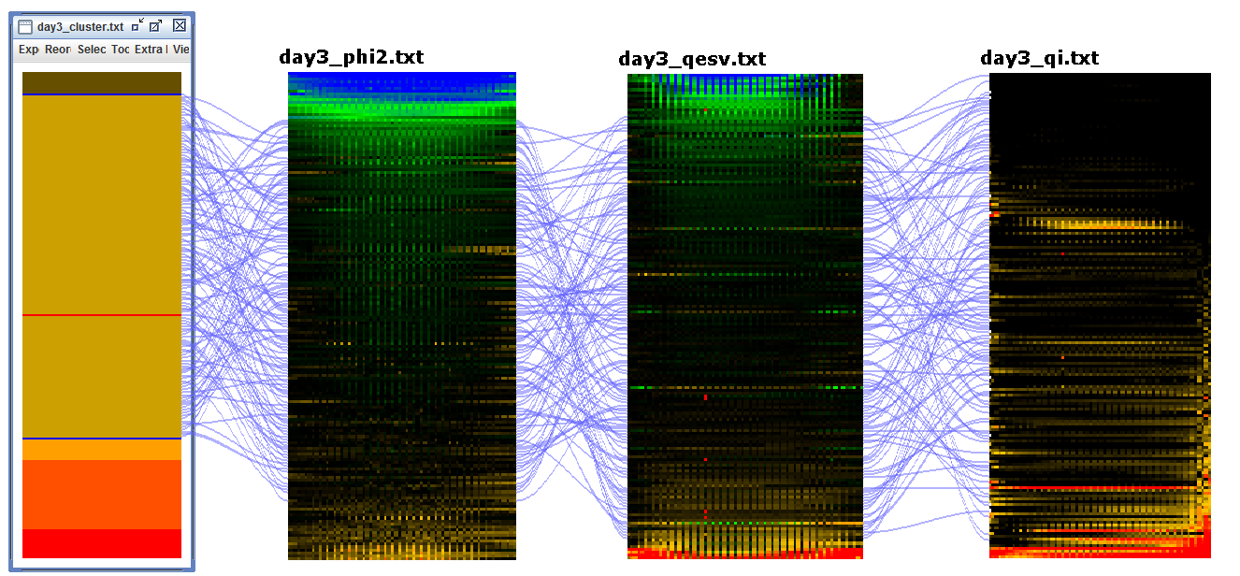

Fluctuating light, cluster 3: low Phi2, high qE, high qI

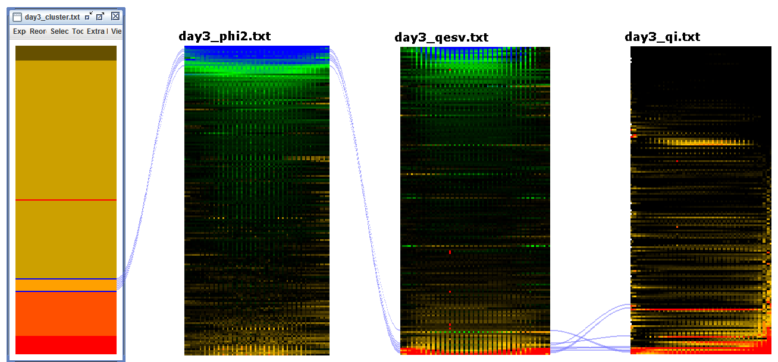

Fluctuating light, cluster 4: high phi2, mid qE, mid qI

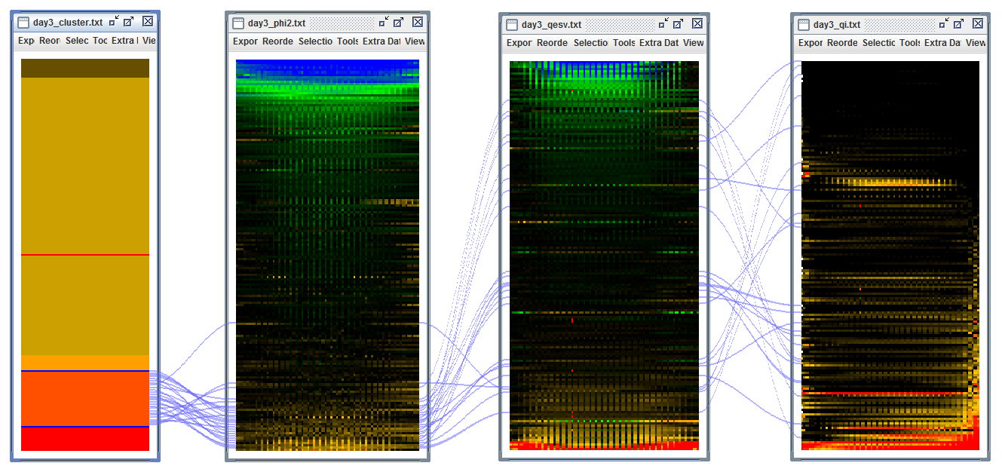

Fluctuating light, cluster 5: Low Phi2, low qE, high qI

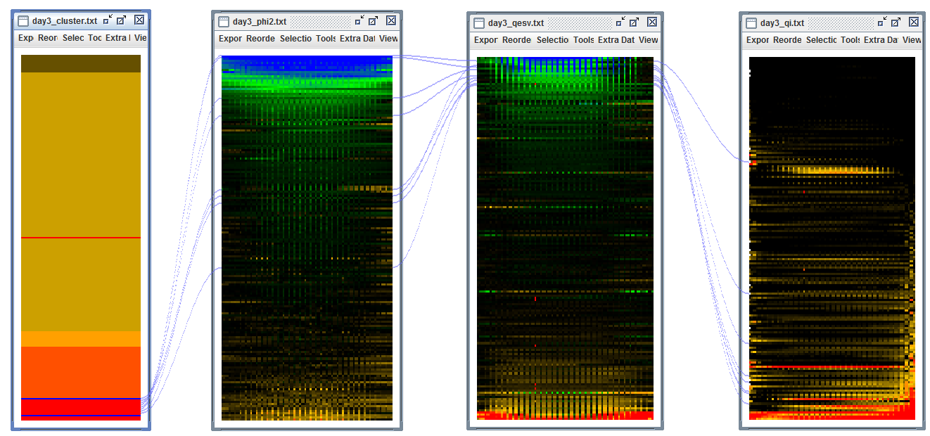

Fluctuating light, cluster 6: Low Phi2, low qE, mid qI

